**Task on Ec2**

1. **Launch one ec2 using Amazon Linux 2 image and add script in user data to install Apache.**



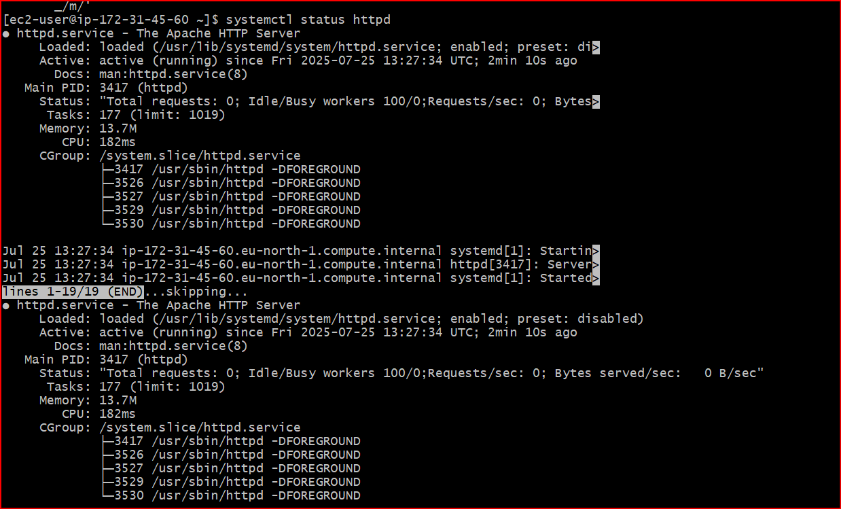

1. **Launch one ec2 using Ubuntu image and add script in user data to install Nginx.**

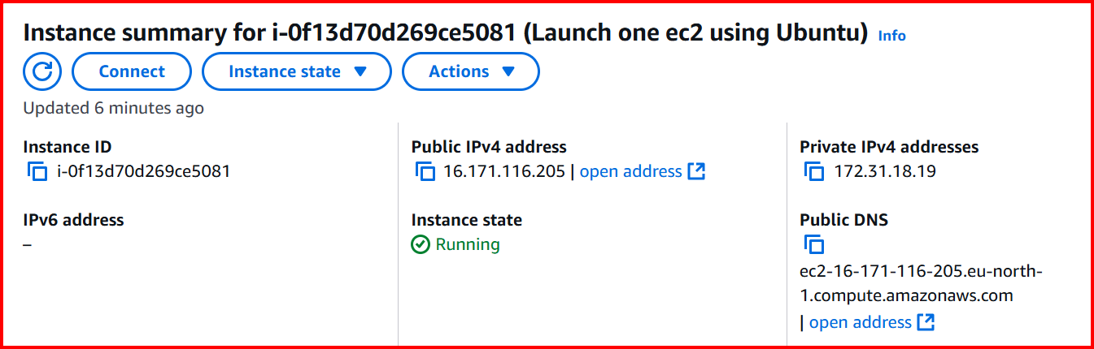

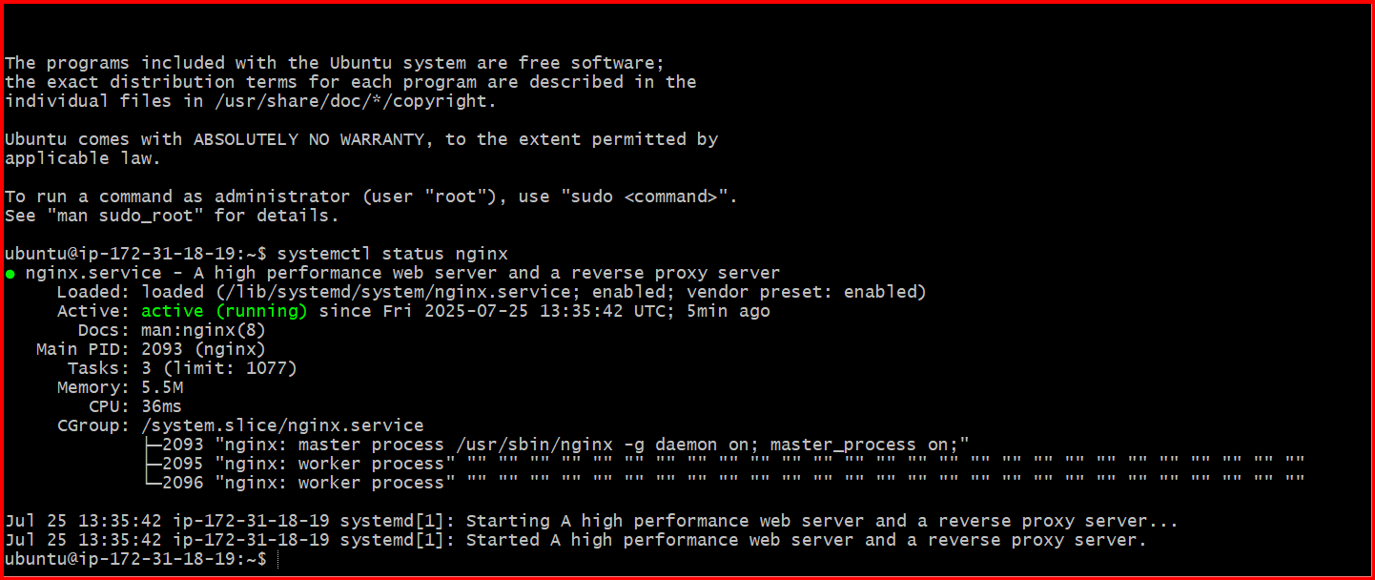

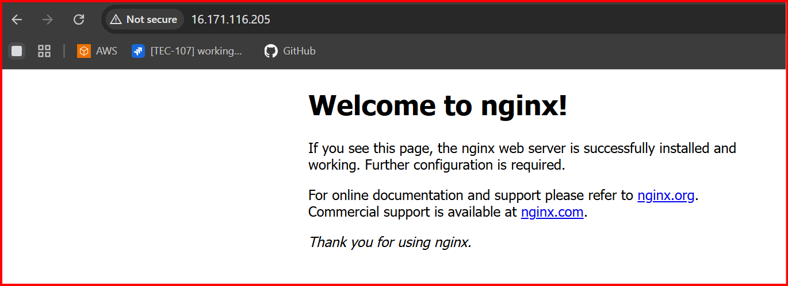

1. Launch one windows server and install tomcat in windows.

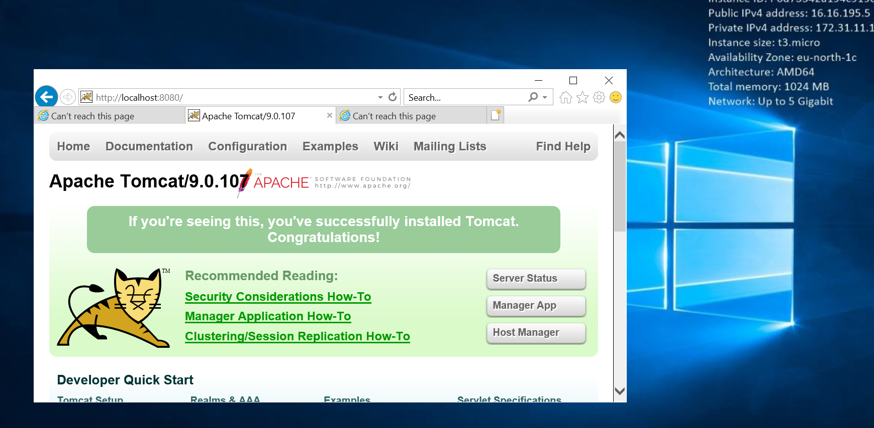

**4.Take snapshot of the instane created in Task 1.**

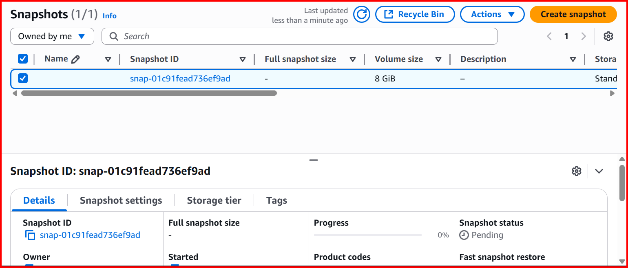

**5.Assign password less authentication for ec2 created on Task 2**

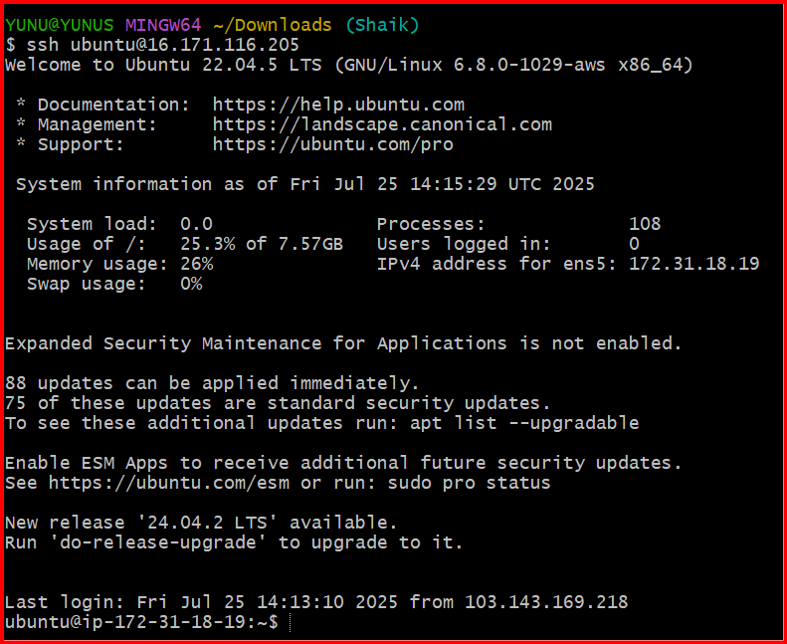

**6.** **Launch any ec2 using spot purchasing option.**

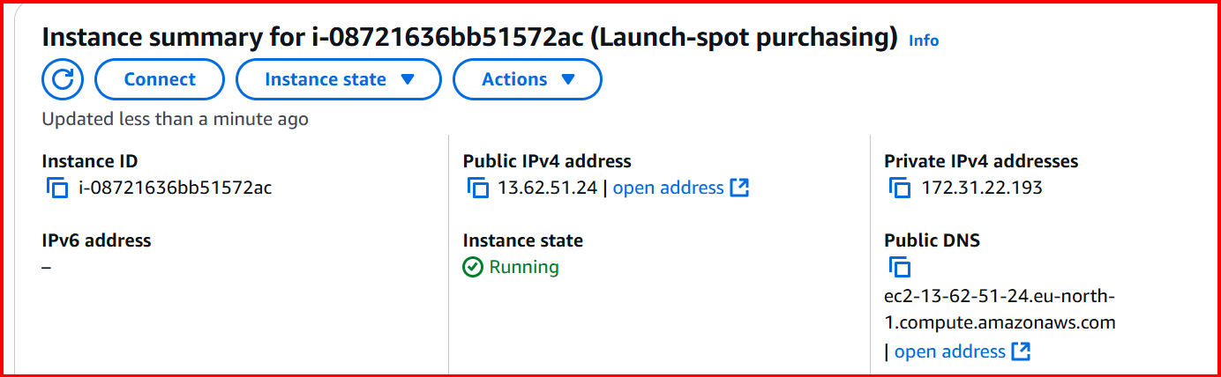

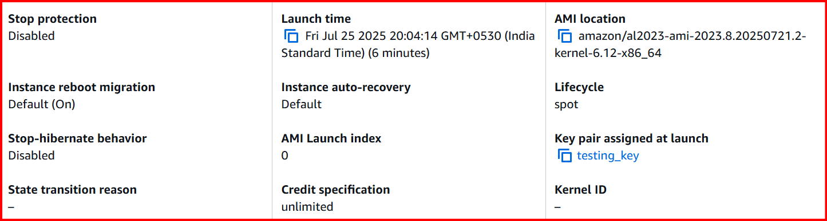

**7.** **Enable Termination policy on ec2 created in Task 2**

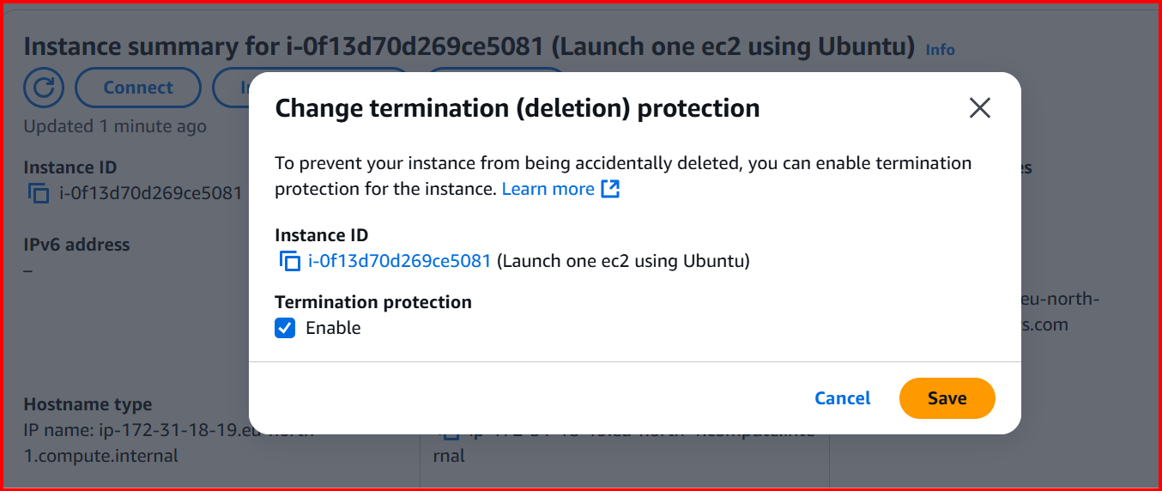

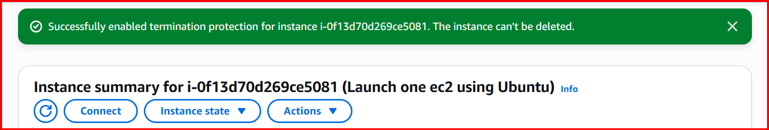

**8.** **Launch one ec2 using Aws CLI.**

